**Assessing Freshwater Ecosystems**

**for their Resilience to Climate Change**

The Nature Conservancy, Eastern North America Division

**Original report: May 28 2013.**

**Revision 1: November 5, 2013**

*Please note that an error was found in the 5/28/2013 product regarding some networks connected to the great lakes. 22 networks were not given credit for being connected to a large lake in their network complexity score and this fix added 10 more networks to our “complex >= 5 sizes” population. These 22 networks have been corrected in the 11/5/2013 datasets and report. These 22 networks were all located in the Great Lakes Freshwater Ecoregion portion of NY and PA within fish subregion” FWE_4CL = GLK_1”.*

**Science Team and Authors**

Mark Anderson, Arlene Olivero Sheldon, Colin Apse, Alison A. Bowden, Analie R. Barnett, Braven Beaty, Catherine Burns, Darran Crabtree, Doug Bechtel, Jonathan Higgins, Josh Royte, Judy Dunscomb, Paul Marangelo

**Abstract:** Resilient stream systems are those that will support a full spectrum of biodiversity and maintain their functional integrity even as species compositions and hydrologic properties change in response to shifts in ambient conditions due to climate change. We examined all connected stream networks in the Northeast and Mid-Atlantic for seven characteristics correlated with resilience. These included four physical properties (network length, number of size classes, number of gradients classes and number of temperature classes), and three condition characteristics (risk of hydrologic alterations, natural cover in the floodplain, and amount of impervious surface in the watershed). A network was defined as a continuous system of connected streams bounded by dams or upper headwaters. We scored the networks based on the seven characteristics, and we identified the subset of 356 networks that contained over four different size classes of streams or lakes. Within each freshwater ecoregion and within smaller fish regions (basins with similar fish fauna), we identified the set of these 356 complex networks that scored above average. Finally, we compared the set of above-average networks against the set of rivers identified by The Nature Conservancy based on their high quality biodiversity features. Results indicated there was a 63% overlap between streams identified for their biodiversity features and those that scored above-average for their resilience characteristics. The later networks are strongholds of current and future diversity, making them good places for conservation action. Lower scoring stream networks should be carefully evaluated with respect to their long term conservation goals.

**Background**

Ecosystem resilience is the ability of an ecosystem to retain essential processes and support native diversity in the face of disturbances or expected shifts in ambient conditions (definition modified from Gunderson 2000). As growing human populations increase the pace of climate and land use changes, estimating the resilience of freshwater systems will be increasingly important for delivering effective long-term conservation. Although the precise species composition in a given area will undoubtedly evolve in response to environmental changes, the ability to identify rivers and streams with the capacity to adapt to these changes, and maintain similar biodiversity characteristics and functional processes under novel conditions, is a critical step towards protecting healthy freshwater systems.

Recent research suggests that the resilience of freshwater systems can largely be characterized by a set of measurable elements such as: linear and lateral connectivity, water quality as shaped by surrounding land use, alterations to instream flow regime, access to groundwater, and the diversity of geophysical settings in the area (Rieman and Isaak 2010, Palmer et al. 2009). In this project, we aimed to quantify each of these factors for 1,438 stream networks occurring across 14 states of the Northeast and Mid-Atlantic region to identify the networks with the highest relative resilience (not taking into account possible restoration strategies). For each factor, we experimented with direct and indirect measures that could be applied consistently and accurately across all stream networks at a regional scale using regional datasets. The metrics we decided on, and our techniques for measuring them, are described in the methods. Not all the elements of resilience were equally suited to measurements at the regional scale, and one element, access to groundwater, was excluded due to data limitations at this scale.

This project was led by the Eastern Conservation Science office of The Nature Conservancy (The Conservancy) in conjunction with a steering committee of freshwater ecologists representing ten states. The analysis built on previously completed projects including a comprehensive stream classification system for the Northeastern US (Olivero and Anderson, 2008), and a spatial dataset of dams and unconstrained stream segments (Martin and Apse, 2011). These datasets were created to provide a tool for region-wide assessments, with funding and guidance from the Northeast Association of Fish and Wildlife Agencies.

We modeled freshwater resilience to inform The Conservancy’s freshwater conservation, restoration planning, and prioritization. This work parallels a terrestrial project where we pioneered an approach to climate change planning that uses a geophysical analysis of land and water to identify places that are high in ecological resilience and biodiversity (Anderson and Ferree 2010, Anderson et. al. 2012). The terrestrial analysis informs the Conservancy’s decisions regarding where we invest our resources in terrestrial protection and management, and where we encourage our partners to engage. In a similar way, this work is intended to inform freshwater conservation efforts in Eastern North America, and will be shared broadly with chapters in the surrounding states and with our many partners working towards freshwater conservation. The terrestrial resilience analysis is complete in the Northeast and Mid-Atlantic and underway in collaboration with seven states in the Southeast. The former may be viewed at: (<http://conserveonline.org/workspaces/ecs/documents/resilient-sites-for-terrestrial-conservation-1>)

(http://www.conservationgateway.org/ConservationByGeography/NorthAmerica/UnitedStates/edc/reportsdata/terrestrial/resilience/Pages/default.aspx)

**Methods**

*Geographic analysis scales*

**Analysis Scale and Study Area**

This was a regional scale analysis based on attributes predictive of resilience that could be mapped at the regional scale. The area studied included 14 states of the New England and Mid-Atlantic regions of the United States: Maine, New Hampshire, Vermont, New York, Massachusetts, Rhode Island, Connecticut, Pennsylvania, Delaware, New Jersey, Maryland, Ohio, West Virginia, and Virginia (hereinafter “the region”). The area covers 797,833 km2 and supports over 13,500 species including a variety of fish, aquatic plants, mussels and other macro-invertebrates (Anderson and Ferree, 2010). Finer scale, site-specific information, will be necessary to apply this information at specific places.

**Unit of Analysis**

The unit of analysis for this study was a **functionally connected stream network**, defined as the set of streams bounded by fragmenting features (dams) and/or the topmost extent of headwater streams (Figure 1). Functionally connected stream networks were mapped using a new anthropogenic barriers dataset including the National Inventory of Dams supplemented by each state’s dataset of dam locations (Martin and Apse 2011). The dam dataset was linked to the National Hydrography Dataset Plus (NHDPlus 1:100,000), which served as the base data for the stream networks. In GIS, each network was identified and given a unique ID, and the attributes discussed below (e.g. length, number of gradients, etc.) were calculated to each network.

**Figure 1. Example of four Functionally Connected Stream Networks.** Network A is bounded by four topmost headwaters and one downstream dam (black bar). Network B, bounded by six topmost headwaters, two upstream dams and one downstream dam, includes one large lake and is considerably longer than network A.

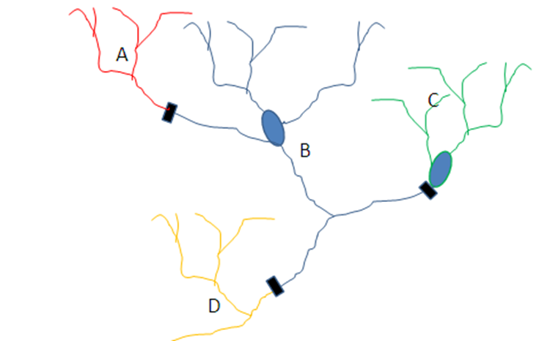

The region evaluated contained over 14,000 functionally connected stream networks, with the vast majority being composed only of small headwaters and creeks (watershed of 100 km2 (38 sq. mi.) or less). We focused the analysis on networks that contained at least one small river (watershed of >100 km2) and that was at least 3.2 km long. This decreased the number assessed to 1,438 which covered 78 percent of all stream kilometers in the region. The latter units ranged up to 6,483 km in length with a mean of 199 km.

**Geographic Stratification**

We used two nested geographic stratification schemes to compare and contrast stream networks, providing a sub-regional context for assessing relative resilience among functionally connected stream networks that have similar fish compositions: **freshwater ecoregions** as defined and mapped by the World Wildlife Fund (Abell et al. 2008), and smaller **fish regions,** which we defined based on the fish species composition of large basins (Figure 2).

**Freshwater ecoregions** provide a global biogeographic regionalization of the Earth's freshwater biodiversity. These units are distinguished by patterns of native fish distribution resulting from large-scale geoclimatic processes and evolutionary history. The freshwater ecoregion boundaries generally, though not always, correspond with those of watersheds. Within individual ecoregions there will be turnover of species, such as when moving up or down a river system, but taken as a whole an ecoregion will typically have a distinct evolutionary history and/or suite of ecological processes (Abell et al. 2008).

Within each freshwater ecoregion, we defined one to four discrete **fish regions** using a cluster analysis of the USGS 8-digit Hydrologic Units (HUC) based on similarities in their native fish composition. The analysis was based on a previously developed list of native species present within each HUC (NatureServe, 2008). The cluster analysis defined up to four clusters within each freshwater ecoregion using similarity of composition (Linkage method: Flexible beta, Distance measure: Sorensen (Bray-Curtis), Flexible beta value of -0.250). To determine the faunal distinctiveness between clusters, we performed an indicator species analysis and calculated a Sorensen’s similarity index using relative frequency (i.e. the percent of HUC’s in a cluster where a given species was present). Clusters within a freshwater ecoregion were recognized as distinct if they were less than 80 percent similar in their respective fish compositions (Sorensen similarity index was <= 0.8). This resulted in four fish regions within the North Atlantic Ecoregion, three fish regions within the Chesapeake Bay Ecoregion, and three fish regions within the Ohio Basin Ecoregion. No distinct clusters were found within the St. Lawrence, Great Lakes, South Atlantic, and Tennessee freshwater ecoregions, probably because only a portion of each ecoregion was contained in our study area. For these ecoregions, the fish regions were identical to the ecoregion (Figure 2).

We used the stratification schemes primarily to compare similar stream networks within an appropriate context. Facilitation of management decisions at the regional, ecoregional, and fish region scale is appropriate for national and state level organizations. The freshwater regions provide broader context to physical patterns such as climate, landform, and temperature, that influence biotic composition, and the within-region analyses ensure comparison of similar systems for relative resilience.

*Assessment Methods*

We developed methods and data for measuring each of seven primary factors that contribute to the resilience of a stream network, and we developed a method for summarizing and integrating the information for each network. One factor, network complexity, was used as an overarching criterion to filter out simple, homogenous networks and thus focus the study on a subset of diverse stream networks likely to offer many options for maintaining diversity and function. The other six metrics were used to quantify physical properties and ecological condition for each stream network. Below we describe each factor and how we measured it.

**Figure 2. Fish Regions and Freshwater Ecoregions**. This map shows the fish regions and freshwater ecoregions within the analysis area of the 14 northeastern states.

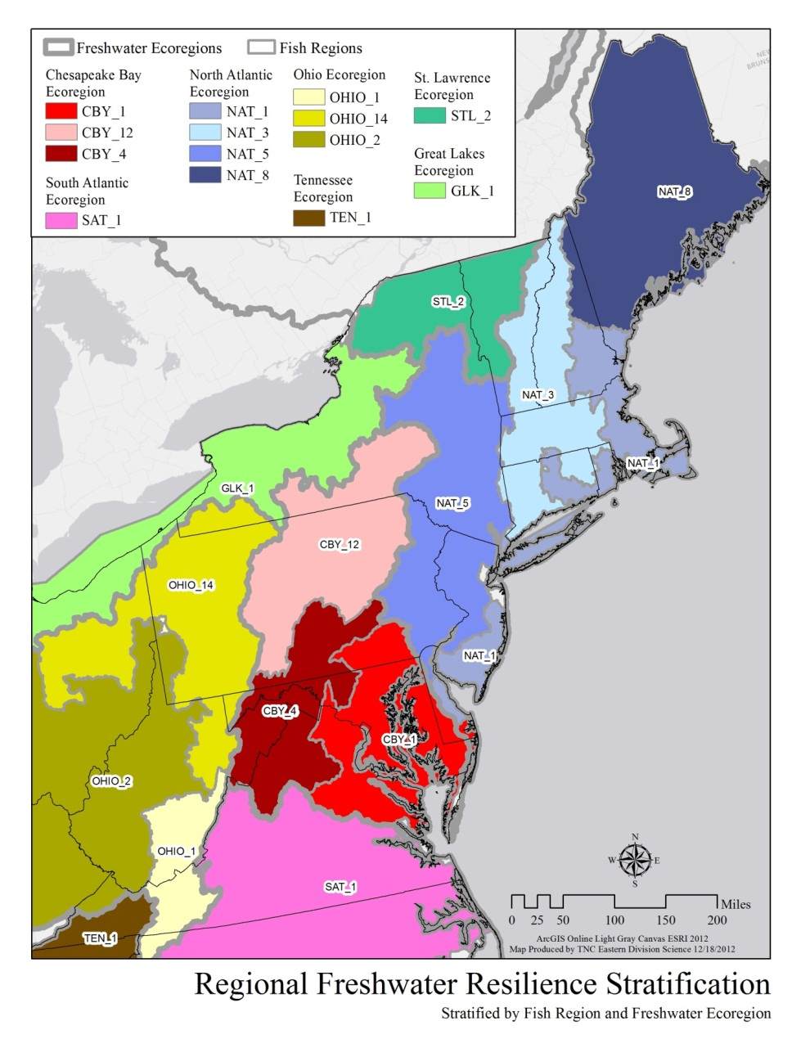

**Summary of Attributes**

We started by calculating over 20 attributes for each network and settled on the following seven key metrics for scoring the networks:

* **Network Complexity:** the number of stream and lake size classes in a network
* **Physical properties:**  factors that create habitat heterogeneity within a network for species to move and rearrange.

1. Length of connected network
2. Number of gradient classes in the network
3. Number of temperature classes in the network

* **Condition characteristics:**  factors that maintain important functions and processes.

4. The degree of natural cover in the floodplain (lateral connectivity)

5. The degree of unimpeded hydrologic flow

6. The cumulative extent of impervious surfaces in the watershed

*Network Complexity*

Network complexity refers to the variety of different sized streams and lakes contained in a network. Stream size and network complexity are critical factors in determining aquatic biological assemblages (Hitt and Angermeier, 2008). The well-known "river continuum concept" (Vannote et al. 1980) provides a description of how differences in the physical size of the stream catchment relates to differences in stream characteristics, from small headwater streams draining local catchments to large rivers draining huge basins. The changes in physical habitat, water volume, and energy source, as streams grow in size are correlated with predictable patterns of change in the aquatic biological communities. The Northeast aquatic habitat classification system (Anderson and Olivero 2008) delineated seven size classes for streams based on their catchment drainage area: headwater, creek, small river, medium tributary, medium mainstem, large river, and great river (Figure 3). These classes were determined by studying similarities in the size classes and biological descriptions across the various state classification systems, and by studying the distributions of freshwater species across size classes. The Northeast classification system also delineated two major lake size classes, small-medium lakes 4.1 – 404.7 hectares (10-1,000 acres) and large lakes >404.7 hectares (>1,000 acres). Because biota and physical processes change with size classes, our assumption is that networks containing a variety of stream and lake sizes will retain more of their historic species composition even as the climate and hydrological regimes change by providing varied potential habitats, including refugia.

Network complexity (Figure 3) was measured as a count of stream and lake size classes found within a functionally connected network, as defined in the northeast aquatic habitat classification system (Anderson and Olivero 2008). The metric ranged from 1 to 9, and was calculated and coded systematically for each network. To ensure that we counted only size classes that had a substantial expression in the stream network, we developed the following criteria based on discussion with experts: size class 1 > 1.6 km length, size class 2 > 3.2 km, size class 3 and up > 4.8 km. For example, a total of 0.5 km length of stream in size class 1 in a network was not counted as an example of that size class because it was too small to represent a full expression of the biota and processes expected for a size 1 stream.

**Figure 3. Network Complexity.** A: schematic showing the seven size classes of streams and lakes. Figure A shows networks of varying complexity. Example 1 has one size (1a), example 4 has four sizes (1a_1b_2_SL) and example 7 contains seven size classes. B: Size classes in relation to the River Continuum Concept. Source: Stream Corridor Restoration: Principles, Processes, and Practices, 10/98, by the Federal Interagency Stream Restoration Working Group (FISRWG).

A: B.

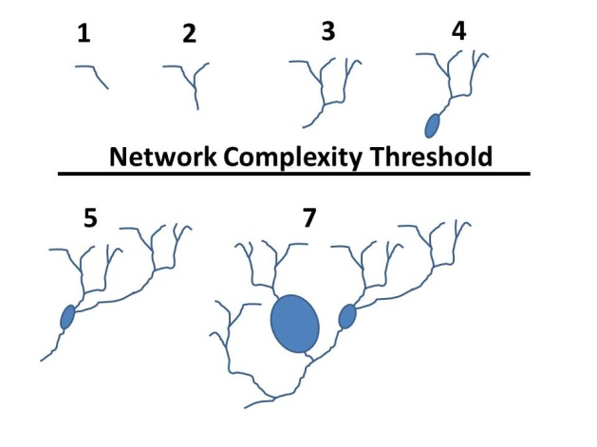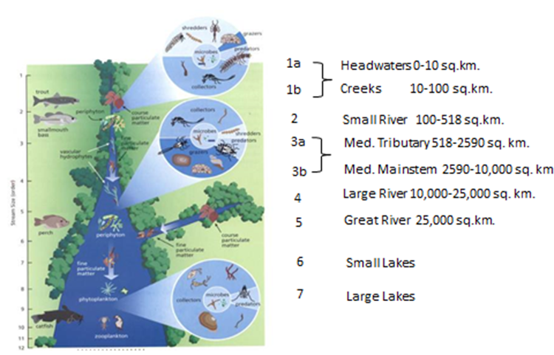

*Physical Properties*

*1. Linear connectivity: length of the connected network*

Connectivity within a network of streams is essential to support freshwater ecosystem processes and natural assemblages of organisms. It enables water flow, sediment and nutrient regimes to function naturally, individuals to move throughout the network to find the best feeding and spawning conditions, and, in times of stress, it enables individuals to relocate where conditions are more suitable for survival (Pringle 2001). There has been considerable impact on the connectivity of river systems in the Northeast due to dams and impassible culverts, causing a substantial decrease in the length of connected stream networks throughout the region (Anderson and Olivero 2011). These changes will have lasting impacts on adaptive capacity for future climate change and other environmental stressors. We assumed that areas with greater linear connectivity are more resilient to environmental change.

We measured linear connectivity by calculating the cumulative length of each functionally connected network (Figure 4). This provided a quantitative assessment for comparison among networks. We used only dams and topmost headwaters as barriers. Road-stream crossings and waterfalls were not used due to uncertainty whether these features were true barriers to movement and inconsistencies in mapping these features across the region.

**Figure 4. Length of the Connected Network**. This figure illustrates the total kilometers of streams for each network, calculated for streams of any size class between fragmenting dams or upper headwaters.

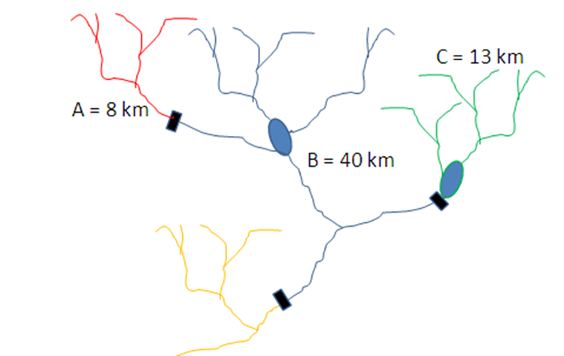

*2. Number of Gradient Classes*

Effectively conserving freshwater biodiversity in a changing climate requires protecting geophysical settings that, over an evolutionary timescale, ultimately drive patterns of diversity (Anderson and Ferree 2010, Palmer et al. 2009, Rieman & Isaak 2010). For stream networks this includes variation in gradient, geology, and temperature, as these factors have long been identified as important in shaping freshwater biodiversity (Higgins et al. 2005). Networks with high variation in these properties capture the variety of available microclimates, habitats, and flow velocity conditions that species can exploit during rearrangement in response to environmental changes. Incorporating information on geophysical diversity allows conservation biologists to better encompass genetic and phenotypic diversity by conserving diverse habitat representations across river basins with appropriate redundancy (Rieman & Isaak 2010). We quantified geophysical diversity for two factors: gradient and temperature.

To assess the number of gradient classes in a connected stream network, we first classified every stream and river segment into one of four possible slope classes, following the “4 level” gradient class recommendations for streams and rivers in the Northeast Aquatic Habitat classification (Streams: <0.1 percent, 0.1-0.5 percent, 0.5-2 percent, >2 percent, Rivers: <0.02 percent, 0.02 < 0.1 percent, 0.1 < 0.5 percent, >= 0.5 percent Anderson and Olivero 2008, Figure 5). The number of distinct gradient classes found in each connected network was tallied and our metric was a count of gradient classes. Based on discussion with experts, we use a minimum criteria of >= 0.8 km total length of a class to qualify as present. This ensured that we counted only gradient classes that had a substantial expression in the stream network.

**Figure 5. Gradient Classes within a Stream Network**. The panel shows an approximation of the four stream gradient classes” Class 1 = 0.0-0.1%, Class: 2 = 0.1-0.5%, Class 3 = 0.5-2%, and Class 4 = >2%.

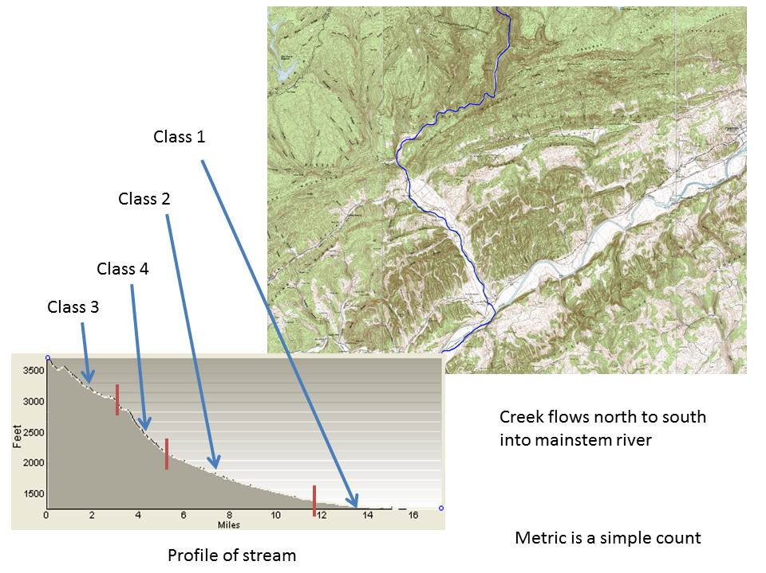

*3. Number of Temperature Classes*

Stream temperature sets the physiological limits where stream organisms can persist and temperature extremes may directly preclude certain taxa from inhabiting a water body. Seasonal changes in water temperature often cue development or migration, and temperature can influence growth rates and fecundity. Many species that are important in coldwater streams are rare or absent in warmwater streams (Halliwell et al. 1999). Many aquatic species, such as brook trout, have adapted to specific temperature regimes, and are intolerant of even small changes in mean temperatures or lengths of exposure to temperatures above certain limits (Wehrly et al. 2007). Ideally a resilient stream network would span a range of current temperatures offering options for both coldwater and warmwater species and provide connected space for species to stay within their thermal preferences in the future.

The Northeast Aquatic Habitat classification assigns every stream reach to one of four expected natural water temperature classes, based on the relative proportion of cold water to warm water species in stream fish composition: cold, cool transitional, warm transitional, and warm. Stream reaches were assigned to a temperature class using a CART model based on stream size, local base flow index, upstream air temperature, and stream gradient (details in Anderson and Olivero 2008). The metric of temperature diversity for this study was a count of the number of temperature classes found in the connected network (Figure 6). To ensure that we counted only temperature classes that had a substantial expression in the stream network, we developed the following criteria based on discussion with experts: size class 1 > 1.6 km length, size class 2 > 3.2 km, size class 3 and up > 4.8 km.

**Figure 6. Quantifying the number of temperature classes within the stream networks**. The panel shows an approximation of the four temperature classes: cold, cool transitional, warm transitional, and warm.

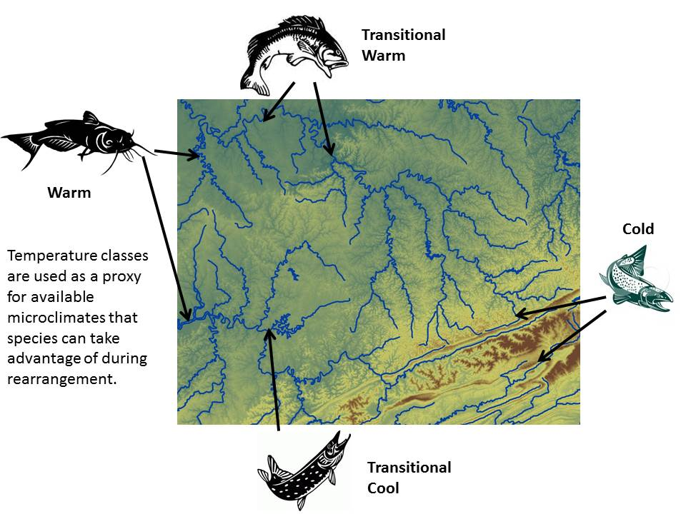

*Condition Characteristics*

*4. Natural cover in the floodplain*

In natural freshwater systems, the floodplain is periodically inundated with water, resulting in the exchange of nutrients, sediments, and organisms necessary for long-term ecosystem health. Periodic floods maintain the physical stream channel, facilitate interactions between terrestrial and freshwater realms, and create habitat for aquatic organisms that feed or spawn in the floodplain. These processes are necessary to support a fully functional freshwater ecosystem. Sustaining the processes requires connectivity between the channel and floodplain, termed “lateral connectivity” (Noe and Hupp, 2005). Naturally vegetated and connected floodplains store flood waters and sediment, reducing channel scour and bank erosion. In addition, maintaining and restoring the floodplains and riparian wetlands to a more natural condition can foster infiltration that serves to recharge groundwater aquifers, helping mitigate extreme low flows associated with more frequent drought conditions. Due to land use change, channelization, and altered flow regimes, the historical extent of flooding has been much diminished in Northeast and Mid-Atlantic streams.

We assumed that areas with more intact floodplains have the potential for increased lateral connectivity and thus resilience to climate change and other disturbances. For each connected network, we mapped the active river area (Smith et al. 2008) of all small to large rivers (watersheds of 100 sq. km or larger). The active river area is the area of dynamic interaction between the water and the land through which it flows, and includes the river meanderbelt, floodplain zone, riparian wetlands, and floodplain terraces. We quantified the extent of various land cover types in this zone using data from the National Land Cover Dataset (NLCD 2006). The degree of development was quantified using a weighted index (Figure 7):

*(1*% high intensity developed) + (0.75 * % low intensity developed) + ( 0.25 *% agriculture.)*

The index ranged from 0 for a floodplain in completely natural cover to 100 for a completely developed floodplain.

**Figure 7. Natural Cover in the Floodplain**. The image shows the floodplain portion of the active river area, colored by land use. The weighted index used to summarize the degree of development apparent in the floodplain was: 1.00*% high intensity developed + 0.75 * % low intensity developed + 0.25 * % agriculture. *Before combining the scores with other metrics they were transformed and normalized so that high scores indicated a more natural condition.*



*5. Unaltered instream flow regime*

The instream flow regime–the amount, frequency, duration and seasonality of water flow though a stream–plays a critical role in shaping the biotic communities of freshwater systems (Poff et al. 1997, Poff et al. 2010, Postel & Richter 2003). Alterations in flow regime due to water withdrawals, dam operations, urban and agricultural land use and associated runoff are common throughout the Northeast and Mid-Atlantic. These alterations significantly impact the species and communities that live in the region’s waters. The specific responses of instream biota to altered flow regimes are not well understood, though a growing body of literature has begun to address this (Bunn and Arthington, 2002, Carlisle et al. 2010, Fitzhugh and Vogel 2010).

We assumed that stream networks with natural, less altered flows are more resilient to environmental and climatic changes. We created an index to measure the relative risk of flow alteration by dams for each connected stream network, by calculating how much of each river’s (size 2 or greater) mean annual flow was potentially stored by upstream impoundments (Fitzhugh and Vogel 2010, Zimmerman 2006). This value, the total cumulative storage potential of all upstream impoundments, was simplified to places all river reaches into one of five risk classes: very low <2%, low 2-10%, moderate 10-30%, high 30-50%, severe 50%+ (derived from Zimmerman 2006, Figure 8). Next, the risk values for all river reaches in a network were combined using a weighted index based on the percentage of river reach miles in each alteration class:

*(%river miles in class 1 * 1) + (%river miles in class 2 * 2) + (etc.)*

The resulting risk of alteration index ranged from 100 for a set of completely unaltered river segments within the network to 500 for a network where every river reach had the potential for severe alteration by impoundments (Figure 8).

**Figure 8. Relative Risk of Flow Alteration due to Dam Storage**. The image shows a connected network with river reaches in three risk classes: very low (35% of cumulative length), moderate (50%) and high (15%). The weighted relative risk index for this example is 245 on a scale of 100 (all reaches unimpeded) to 500 (all reaches severely impeded). *Before combining the scores with other metrics they were transformed and normalized so that high scores indicated a more natural condition.*



*6. Intactness of the watershed and impacts on water quality*

Water quality, and consequently the biotic condition in the stream, declines with increasing watershed imperviousness (CWP, 2003, Cuffney et al. 2010, King & Baker 2010, Wenger et al. 2008), and also with other changes in the land cover of the watershed such as the prevalence of agriculture and energy extraction (Bolstad & Swank 1997, Gergel et al. 2002, Mattson & Angermeier 2007). The adaptive ability of freshwater biota depends on the fitness of their populations which is partially a function of water quality. Water quality in the region is highly variable due to extensive urban and suburban development, the prevalence of agriculture in valleys and floodplains, and energy extractive activities. We assumed that stream watersheds with few impervious surfaces should, on average, have higher water quality.

To measure watershed intactness, we summarized the cumulative degree of impervious surfaces (paved roads, parking lots, development, etc. ) present within the drainage area of each stream reach based on the NLCD 2001 Imperviousness dataset. Each reach was assigned to one of four impact classes: class 1 = 0-0.5%, class 2 = 0.5% - 2%, class 3 = 2%-10%, class 4 >10% (derived from Baker and King 2010). The results were combined into a weighted index using a weighting scheme similar to the one we used for the index of flow alteration:

*(% cumulative stream length in class 1*1) + (% in class 2*2) + (% in class 3*3) + (etc.)*

The resulting score ranged from 100 in a network with no impervious surfaces to 400 in a network where every reach had more than 10% impervious surfaces in its watershed (Figure 9).

**Figure 9. Index of Cumulative Upstream Imperviousness**. This example shows a connected network with stream reaches in three risk classes: Class 1 (35% of cumulative stream length), Class 3 (50% of cumulative stream length) and Class 4 (15% of cumulative stream length). The weighted risk index for this example is 245 on a scale ranging from 100 (no impervious surfaces in any watershed) to 400 (all reaches with over 10% impervious surfaces in their watershed). *Before combining the scores with other metrics they were transformed and normalized so that high scores indicated a more natural condition.*



**Integrating the Metrics**

We transformed all individual factors so that positive scores always represented relatively high resilience. We log transformed any non-normally distributed variable (i.e. length) so that it approximated a normal distribution. We normalized the scores within fish regions and freshwater ecoregions as described below.

**Freshwater Ecoregion Geography**

To identify stream networks that were above average for physical properties or condition relative to others within each freshwater ecoregion, we calculated the mean and standard deviation of each variable within each ecoregion. Using the means and standard deviations, we converted all raw variable scores to standardized normalized scores (z-scores, with mean of zero and a standard deviation of one), so that all variables were on a common scale of relative values for each metric and would have an equal influence on the combined score. For each network, we summed the values for each of the three physical properties metrics (length, gradient and temperature) and divided by three to generate a final index of physical properties. Likewise we summed the values for the three condition factors (floodplain naturalness, risk of flow alteration, and impervious surfaces) and then divided by three to create an index of condition.

**Fish Region Geography**

To identify stream networks that were above average for physical properties or condition relative to other functionally connected stream networks in the same Fish Region, we repeated the steps above, only this time we calculated the mean and standard deviation for each variable within each fish region.

**Analysis and Ranking**

Our final ranking was based on all seven variables discussed above. For every network we calculated a complexity score that ranged from one to nine, and a combined relative score for physical properties and condition within the fish regions and freshwater ecoregions.

Complex Networks and Relative Resilience Ranks:

Because stream size is a variable of such fundamental importance to stream diversity and function, we applied a threshold of **five size classes** per network to identify a subset of stream networks that were most likely to be resilient, assuming that networks with fewer size classes were more vulnerable to environmental changes due to habitat diversity limitations. This threshold needs more study, but we found some support for the five size class threshold in our tests of trends in the other calculated variables (see threshold section and Table 1 later in the document).

Networks that had five or more size classes (herein “complex networks” Map 1) were placed into one of five resilience categories. The categories reflect the score of each complex network with respect to the mean score for all networks (networks of any level of complexity that contained a size 2 river) in the geography. We considered the mean score to be the range of values included within one-half standard deviation above or below the calculated mean. The categories reflect the resilience score of the network **relative** to the other networks within the fish region or freshwater ecoregion. The criteria were as follows:

Highest Relative Resilience

1. Scores for physical properties and condition characteristics were each >=0.5 SD (above average) compared with all functionally connected stream reaches assessed within their freshwater ecoregion or fish region, or
2. The sum of the physical properties and condition scores was at least 1.5 SD above the mean and the lowest score was between -0.5 and 0.5 SD (within the range of the mean) within their freshwater ecoregion or fish region.

This group contained the highest scoring complex networks. They scored substantially above the mean in both physical properties and condition, or they were extremely high in either physical properties or condition and only slightly low in the other attribute. We calculated scores at both the fish region and ecoregion, using the highest one for our final score determining inclusion in this category. This corrected for the occasional instance when networks in a given fish region had such high mean scores that those scoring below the mean were still some of the best in the freshwater ecoregion. (Note that some fish regions and freshwater ecoregions had identical boundaries and were not affected by this (Figure 2.)

High Relative Resilience

1. Scores for physical properties and condition characteristics were each above the calculated mean (> 0 z-unit) but one or both were less than 0.5 SD within their freshwater ecoregion or fish region, or
2. The sum of both scores was at least >1 SD above the mean and both the physical property and condition score were between -0.5 and 0.5 SD (within the range of the mean) for their freshwater ecoregion or fish region.

This group contained the second highest scoring complex networks. They were slightly above the mean in both diversity and condition, or they were well above the mean in either diversity or condition and slightly below the mean in the other attribute.

Mixed Relative Resilience: Condition Low

1. Scores for physical properties were above the calculated mean (>0) for the fish region , and condition was at or below zero (the calculated mean).

This group contained complex networks that scored above average in diversity, but at or below average in condition. Their diversity scores were not so high that the network qualified for the high category based on a sum of their diversity and condition scores.

Mixed Relative Resilience: Diversity Low

1. Scores for condition characteristics were above the calculated mean (>0) for the Fish Region, but the physical property score was at or below zero (the calculated mean).

This group contained complex networks that scored above average in condition, but at or below average in diversity. Their condition scores were not so high that they qualified for the high category based on a sum of their diversity and condition scores.

Low Relative Resilience

Complex networks where the relative scores for physical properties and condition were both at or below zero (the calculated mean).

Non-complex Networks: Networks containing less than five size classes of streams or lakes were not included in the final results although the calculations for all networks and the relative scores for physical properties and condition attributes are included in the accompanying dataset.

**Threshold for Complex Networks.**

Because the five size-class threshold for a complex network had a potentially large effect on the final set of stream networks identified, we explored its implications by examining how the proportion of stream networks at each level of complexity (1 to 9) scored in each relative resilience category (Table 1). The results showed that networks with a complexity of five or more size classes had an increasing proportion of their occurrences in the high or highest resilience categories (i.e. a positive sloping trend line across categories from below average to highest, Table 1, column 7). This provided assurance that many of the same networks might have been identified even without the threshold, as well as support for the use of the threshold in reporting and mapping results. Thus, by focusing our evaluation and mapping on the 356 most complex networks, we were focusing on the networks most likely to be in a relatively high resilience category and of likely sufficient complexity in size class distribution to provide critical varied potential habitats. Collectively, these covered 59 percent of all stream miles in the region.

**Comparison with TNC Freshwater Portfolio**

We overlaid and compared the results of this analysis with the results of the Conservancy’s portfolio of priority rivers chosen based on their current biodiversity value and high condition. Portfolio rivers were compiled from nine ecoregional assessments completed by the Conservancy from 1999 to 2009 (The Nature Conservancy, 2012) and contain a selective subset of all rivers that include viable populations of rare species or the best examples of representative river types. To be included in the Conservancy’s portfolio, each river met criteria related to its size, condition, and watershed. The goal of the assessment was to identify a portfolio of river networks that, if conserved, would collectively protect the full biological diversity of an ecoregion.

**Table 1. The proportion of network occurrences in each relative resilience category**. This table shows the ranking of stream networks (n = 1438) sorted by their complexity level. Networks with only a single size (complexity = 1) had 68 percent of their occurrences in the below average category and zero in the highest relative resilience category, whereas networks with nine size classes had 100 percent of their occurrences in that category. Networks with a complexity >=5 sizes had a positive sloping trend line across categories.



**Results**

We mapped the 356 complex networks by their relative physical properties score (Map 2) and relative ecological condition score (Map 3) in order to visually explore the stream identities and geographic pattern of the results. The combined results of physical properties and condition scores within the fish regions and freshwater ecoregions placed the networks into one of the relative resilience rank categories (Map 4).

The results identified 131 networks, containing 100,601 kilometers of streams and rivers, as being in in the highest category for relative resilience. These were the complex networks with the highest scores for both physical properties and ecological condition in their fish region or freshwater ecoregion (Map 4 Table 2). The longest of these highest resilient networks included the St. John, Roanoke, Chowan, Potomac, Allegheny, Delaware, New, West Branch Susquehanna, Rappahannock, and Aroostook. The highest number (75) and length (40,795km) of these networks were found in the North Atlantic freshwater ecoregion. These networks in the North Atlantic made up 80% of the total miles of all stream and river miles within complex networks and 34% of all stream and river miles in this ecoregion. Considering the top two resilience categories together revealed that the Ohio freshwater ecoregion also contains a large percentage of streams and rivers within these top two high resilience ranks (77% of all complex network miles, 25% of all stream and river miles), although it contains a lower amount of the highest ranking miles than the North Atlantic.

**Table 2. Complex Networks by Rank Category and Fish Regions**. This table shows the 356 networks that include at least five stream or lake types displayed by their rank category within Fish Region and Freshwater Ecoregion. Results are presented in total kilometers of the stream and rivers within these categories (A) and by total numbers of networks (B). All scores are relative to their fish regions. Mixed networks are relatively high in either diversity or condition but below in one criteria, and last are networks with resiliency scores below the average in both diversity and condition. NAT = North Atlantic Ecoregion, CBY = Chesapeake Ecoregion, OHIO = Ohio Ecoregion, GLK = Great Lakes ecoregion, SAT = South Atlantic Ecoregion, STL = St. Lawrence ecoregion, TEN = Tennessee ecoregion.

**A.** 

**B.**



The Nature Conservancy’s freshwater portfolio of rivers selected for their high quality biodiversity shows a high correspondence with those identified as above-average for their resilience characteristics. The portfolio selection process was focused on size 2 or larger rivers and did not include small headwaters and creeks (with a few exceptions). In total 63 percent of the portfolio river kms fell into the two highest rank categories for relative resilience (Table 3, Map 5) and another 9 percent corresponded to non-complex networks that scored in the two highest rank categories for physical properties and condition. Only four percent of the portfolio river kms ranked in the lowest category for relative resilience and most of those were in the non-complex networks, which might represent isolated occurrences of river reaches containing rare species. Looking across all size 2 or larger rivers in the region, 31 percent were in both the Conservancy portfolio and the two highest resilience categories, 19 percent were in the Conservancy portfolio only, and 22 percent were in the two highest resilience categories only. This was significantly different from what you would expect by random chance (p = 0.000, Chi-square test).

**Table 3. The Nature Conservancy’s Freshwater Portfolio Rivers by Relative Resilience Categories.** In total the Conservancy’s portfolio includes 32,766 kilometers of rivers of which 63 percent ranked in the two highest categories for relative resilience (i.e. were in complex networks and above the mean for both diversity and condition) by this analysis



**Discussion**

We developed and conducted a region-wide analysis of freshwater stream networks to estimate the capacity of each network to maintain diversity and function under climatic and environmental change based on the evaluation of seven key stream characteristics. The results provide new information for making prioritization decisions about freshwater conservation that will produce enduring outcomes. Comparing the stream networks identified by this analysis as being above-average in relative resilience with those of a previously completed prioritization of streams based on their high quality biodiversity features revealed a 63 percent overlap. We envision that this analysis will likewise shape the work of our partners by highlighting issues and opportunities for protection to maintain the stream networks highly ranked for relative resilience, and restoration for those networks where conservation activities could increase their resilience.

Previous freshwater conservation planning efforts have focused on the current condition or the distributions of target species. However, because the location of species populations are likely to change with changing climatic conditions, it is uncertain how valid these efforts will be in the future if they have not incorporated the projected long-term adaptability of the target systems to climate change. Given the evidence that temperature regimes will significantly change during the coming century, this analysis provides important information for the strategic allocation of limited conservation resources.

Results of this analysis can help direct conservation efforts towards stream networks that are likely to remain complex, adaptable, and diverse systems in the face of environmental changes. By employing and encouraging a long term ecosystem function-based perspective on stream networks, the results should help agencies, private companies, local governments, and conservation organizations decide which conservation actions are most likely to be effective investments in ecological values. Analyses such as this one provide a decision basis so that resources allocated today will likely yield benefits well into the future. We emphasize that local knowledge of any particular high scoring stream network will be needed to inform decisions about or restoration. Moreover, we caution that the limited resources used for environmental conservation, even with careful prioritization, may not be adequate to protect the entire system from all future changes.

We do not expect that these stream networks will stay the same over time. In contrast, this analysis was predicated on the assumption that freshwater networks with relatively higher levels of seven resilience factors will adapt to a changing climate while continuing to sustain diversity and function (definition modified from Gunderson, 2000). Essentially, we identify stream networks that offer a wide diversity of options and microhabitats for species, but we do not predict exactly how the dynamics between streams and climate will play out. Presumably, the network’s species composition will change with climate, and likewise, processes will continue to operate, though not in the same range of variation that they currently do. Thus, a resilient network is a structurally intact geophysical setting that sustains a diversity of species and natural communities, maintains basic relationships among ecological features and key ecological processes, and allows for adaptive change in composition and structure (Anderson et al. 2012).

We evaluated factors that drive the adaptive capacity of stream networks and that could be modeled in GIS with confidence at the regional scale. The seven factors we measured are known to strongly influence biological communities occupying stream networks (Wenger et al. 2008; Palmer et al. 2009, Angermeir and Winston, 1998, Frissell et al. 1986), and they are all slow-response variables in natural systems that bolster the resilience of the system by facilitating the recovery of the system after a disturbance. For example, longer networks have greater capacity to recover from disturbances due to interactions across multiple scales and among ecological components with redundant functions (Walker et al. 2006), and longer stream networks provide a greater diversity and multiple occurrences of habitat types, share biota, and share the functional flow of nutrients, sediment, and other longitudinal processes such as providing “seed stock” to repopulate lost habitats.

The factors related to physical properties emphasized those stream characteristics that create habitat diversity. For example, multiple gradient and temperature classes promote greater habitat diversity through changing the physical and energetic characteristics of the channel (Allan 1995). The gradient diversity leads to variation in substrates, riffle/pool structure, micro-temperature refugia, and other related habitat structure which different species and aquatic communities can exploit. Under variable climatic conditions, connected stream networks with multiple temperature classes allow species to shift locations and take advantage of micro-climate variation to stay within their preferred temperature regime. Thus, long stream networks with a high complexity of physical habitat structure are expected to provide more future options and refuges to resident species, buffering them from changes in the regional climate (Willis and Bhagwat 2009) and slowing the velocity of change (Isaak and Rieman 2012, Loarie et al. 2009).

The factors used to assess condition of the connected stream networks were designed to reveal different aspects of resilience than the physical properties. While the physical properties emphasized habitat options, the condition parameters focused on the relative ‘intactness’ of ecological processes related to natural habitat, water quality and quantity. For example, natural cover in the floodplain provides information on the lateral connectivity between the stream and a natural cover riparian zone and floodplain that is critical to maintaining material exchange and hydrologic dynamics along a river system (Smith et al. 2008). Likewise, the risk of alteration of the natural flow regime from dam impoundment storage is important in this region where impoundment and control of stream flows has been shown to influence biota, change seasonal flow patterns, ecological processes such as nutrient transport and sediment movement Finally, cumulative impervious cover is correlated with ecological stream degradation through changes in water quality and habitat complexity (Cuffney et al. 2010; Violin et al. 2011, King and Baker 2010, CWP 2003). When integrated into a single index, the three condition metrics showed far more below average complex stream networks than the physical properties metrics (Map 2). This suggests that there is more significant alteration of stream condition than physical setting. This is logical, as standard development practices of human communities readily impact stream condition, but alteration of the physical setting of streams is much more difficult and rarer. In fact, the physical setting alteration of stream networks could only be significantly changed through dam construction or mining activity in this region.

The physical property and condition scores often painted a very different picture of the stream networks. The majority of stream networks analyzed in the Central Appalachian Region, Mid-Atlantic Piedmont, exhibited high physical properties scores (Map 1). This reflects the widely varied topographic conditions, large elevational differences in these regions, and relatively low human populations or density of dams, factors that create large connected stream networks of multiple size, gradient, and temperature classes. In contrast, networks in the low elevation sections of the Mid-Atlantic region often had average or below average scores for condition, reflecting the intensity of anthropogenic land uses in these areas.

Given the inherently different evaluation process employed by this analysis compared to The Nature Conservancy’s identification of a portfolio of high quality biodiversity sites, the significant correspondence between the selected stream kilometers was reassuring and interesting. In the Conservancy’s selection process, conservation planners were tasked with identifying river reaches that supported known populations of rare species, important natural communities, and the most viable examples of all small to large river system types. The Conservancy portfolio is biased toward reaches with a greater body of natural heritage inventory and higher levels of potential biodiversity. On the other hand, the resilience analysis focused on all contiguous connected stream networks including small streams as well as larger rivers regardless of level of inventory. Moreover, the analysis purposely focused consideration on measures of ecosystem function and complexity rather than a consideration of rare species presence to force the identification of highly functioning systems. The finding that 63 percent of the portfolio rivers ranked in the highest two categories for potential resilience and that 30 percent of all small to great rivers in the region were selected by both methods, suggests that high quality biodiversity in river systems is correlated with networks of higher resilience. Areas that have both are strongholds for both current and future biodiversity and suggest good places for conservation action.

Our initial list of possible resilience factors included a broad array of topographical, geological, hydrological, environmental regime, and human impact variables. From the long initial list, a manageable subset was chosen based on availability of region-wide data, statistical correlation analyses among variables, and an understanding of which parameters most reflected resiliency. However, several limitations of the analysis became apparent during the project, and we had to discard some important parameters. For example, groundwater influence stabilizes temperature deviations in stream networks (Chu et al. 2008), but there was no consistent data set available at an appropriate resolution for the analysis. While the USGS produced a 1 km2 resolution model of baseflow contribution to streamflow for the entire US that was integrated into the temperature class model (Olivero and Anderson, 2008), this resolution was too coarse to capture the additional local scale thermal refugia we hoped to measure. Road-stream crossings and waterfalls were also omitted from the barrier dataset due to inconsistencies of data across the study area. We were unable to map water withdrawals and returns because there was no consistent protocol among states to identifying cumulative water withdrawals and insufficient information to determine the net water loss from the system. Attempts to use agricultural land use as a surrogate for water withdrawal were unsatisfactory because of the wide variation in irrigation practices across the large analysis region. Finally, we mapped the extent of impervious cover within the watershed as a surrogate for water quality, a decision which is well supported in the literature, because it is consistently mapped at the regional scale. Initially, we considered including specific constituent measures and EPA 303(d) listings, but the variability among states in both sampling protocol and intensity and in designations of impaired waters rendered them unusable at this scale.

We do not know exactly how sensitive the results of this analysis were to the inclusion or omission of any single variable, but we discovered that many potential variables were statistically correlated with each other. The final seven metrics chosen for inclusion in this analysis were the most uncorrelated of an original set of over 25 potential variables. We often had to choose one variable out of several that appeared to be conveying similar information. For example, network dendricity was highly correlated with network length and we decided to use only the latter. Similarly, the density of road/stream crossings and upstream percent forest were highly correlated to measures of impervious surfaces so only the latter was retained. Across the complex networks and the seven primary variables, the highest remaining correlation was between the diversity in size classes and length (r = 0.64) which supported our use of complexity as a reporting threshold rather than as a variable integrated into the physical diversity index. Stream length was slightly correlated with the number of temperature classes (r = 0.32) and the number of gradients (r = 0.32), but all three were retained in the physical diversity index. The amount of impervious surfaces in the watershed had some correlation with floodplain naturalness (r = 0.60) and dam storage (.33), but again all three were retained in the condition index because the team felt they were still measuring important different types of impacts on streams. We felt the final set of variables used provided robust and fairly stable results, as well as having been suggested as indicators of resiliency to climate change in previous freshwater stream system studies (Rieman and Isaak 2010, Palmer et al. 2009).

This analysis has the potential to inform restoration and mitigation efforts. Stakeholders prefer restoration and mitigation funds be allocated to projects that provide positive ecological outcomes for generations to come. Currently, the main mechanism to accomplish this is via best professional judgment, which is subject to unintentional bias and regional knowledge limitations. The outputs of the analysis can suggest stream networks that possess a low cost:benefit ratio that will be valuable well into the future. By encouraging the condensation of mitigation activities into stream networks that are resilient, the expected benefits integrated over time can be increased over opportunistic project selection. This directly fits under the US Army Corps of Engineers recent mitigation hierarchy guidance in which mitigation credits are expected to provide ecological benefits in perpetuity. Direction of government-funded cost-share best management practices programs also could benefit from this analysis by directing tax-payer generated funds to projects that are likely to produce decades-long ecological benefits.

We hope this analysis leads to further refinement of the methods, and that researchers and partners will help us test these assumptions and revise and improve our understanding of how well our freshwater ecosystems will endure and respond to climate change. Further prioritization could be generated by overlaying various change projections with the current analysis results. Current models predicting environmental shifts due to climate change and land use alterations could be compared to the existing results. Areas of significant environmental regime shifts and high resiliency should be targets for further study to determine the realized ecological consequences and biotic responses. Likewise, better mapping and quantification of refugia and microhabitat usage by aquatic species would be useful for refining the model. A rigorous finer-scale analysis of what freshwater ecological system types are represented by the streams in the highest relative resilience categories could be informative for conservation planning. The outcome may show resource managers what system types may be lost to future large scale environmental drivers.

**Map 1. The Complex Networks**. This map shows the 356 networks that include at least five stream or lake size classes.

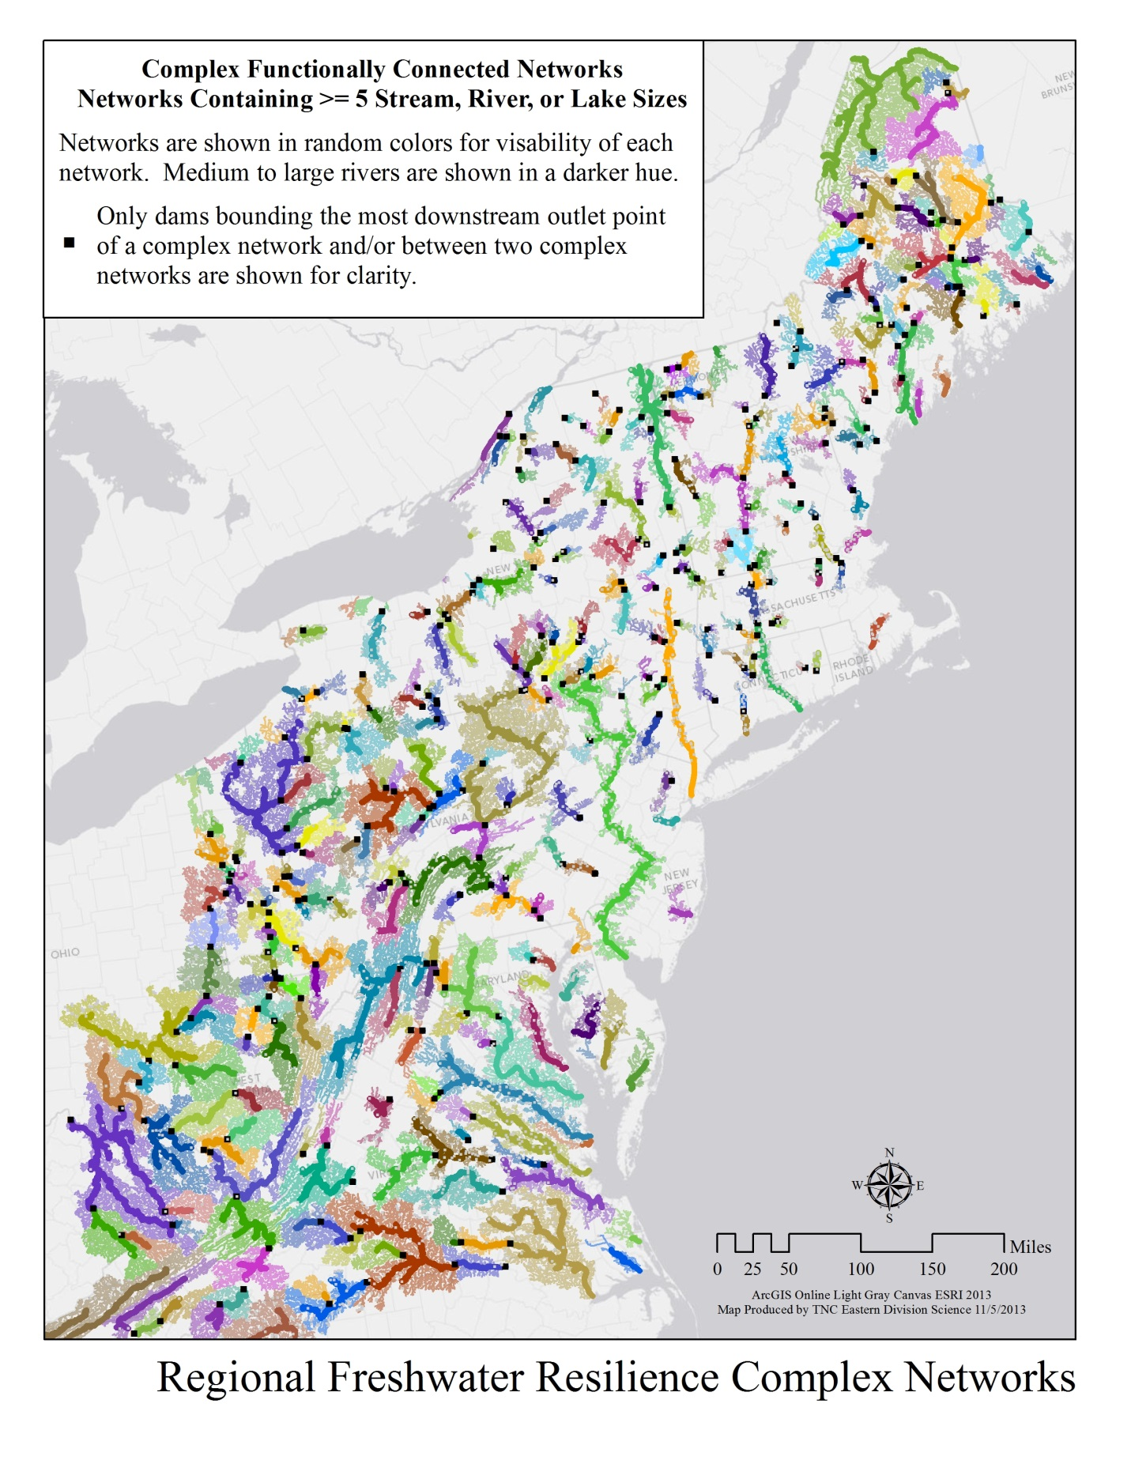

**Map 2. Physical Properties**. This map shows the 356 networks that include at least five stream or lake size classes displayed by whether they are above or below average for habitat diversity within their fish region. Habitat diversity is based on network length, number of gradients and number of temperature classes. Note these complex networks are typically more diverse than the total set of networks containing a size 2 or greater river (1438) in the analysis

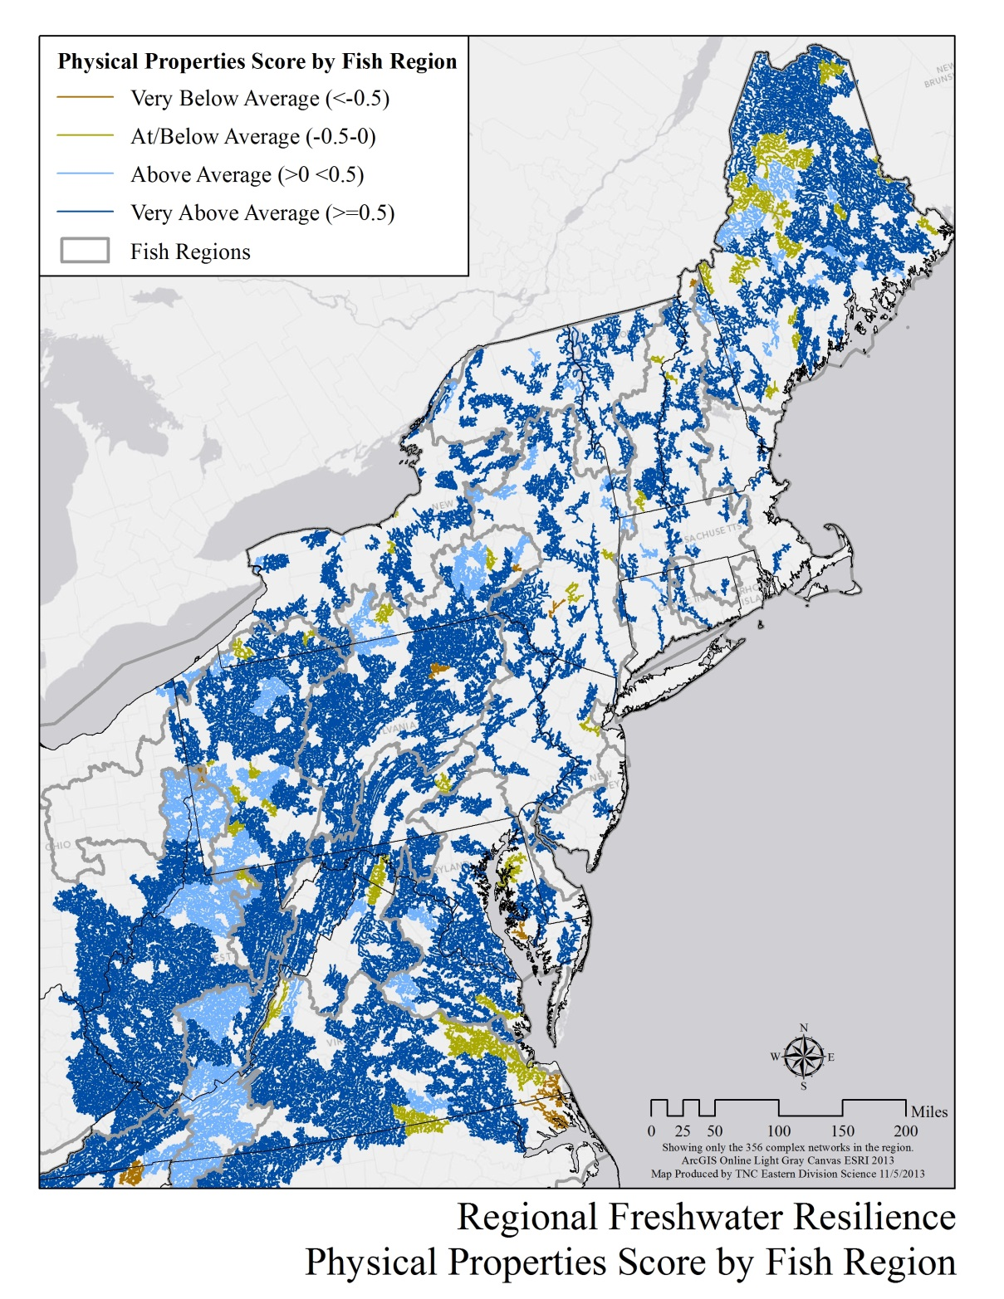

**Map 3. Relative Condition Characteristics**. This map shows the 356 networks that include at least five stream or lake size classes displayed by whether they are above or below average for ecological condition in their fish region. Relative condition is based on the naturalness of the floodplain, the risk of flow alteration based on impoundments, and the degree of impervious surfaces in the upper watershed.

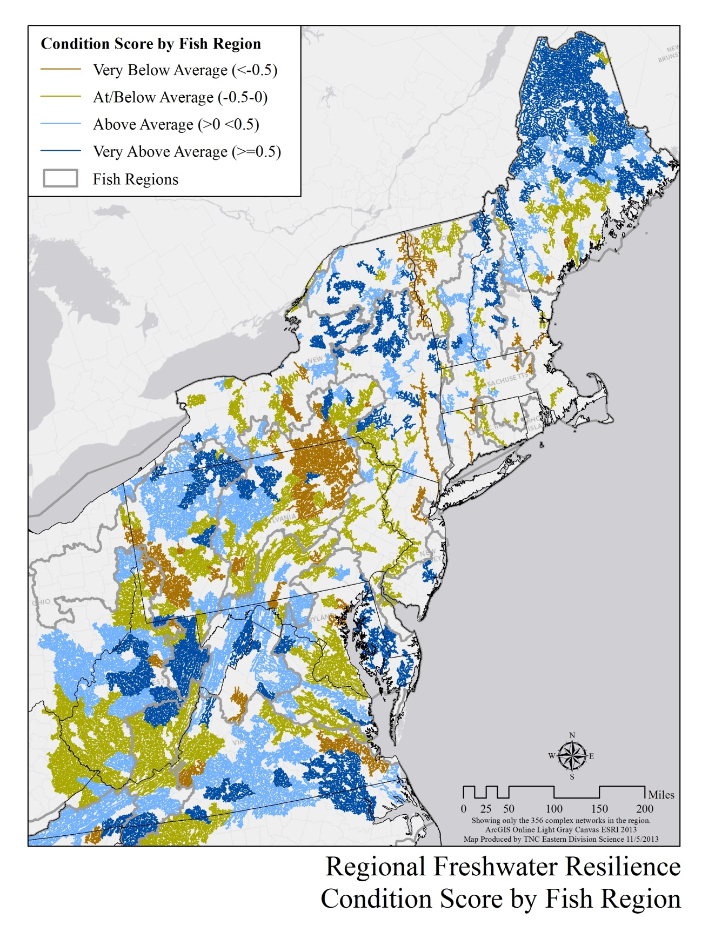

**Map 4. Integrated Rank Categories.** This map shows the 356 complex networks (networks with at least five stream or lake size classes) displayed by their integrated resilience class. Highest Relative Resilience networks are far above average, High Relative Resilience networks are above average, mixed networks are high in either diversity or condition but below in one criteria, and below average networks are below in both diversity and condition in relation to all other networks included in the assessment.

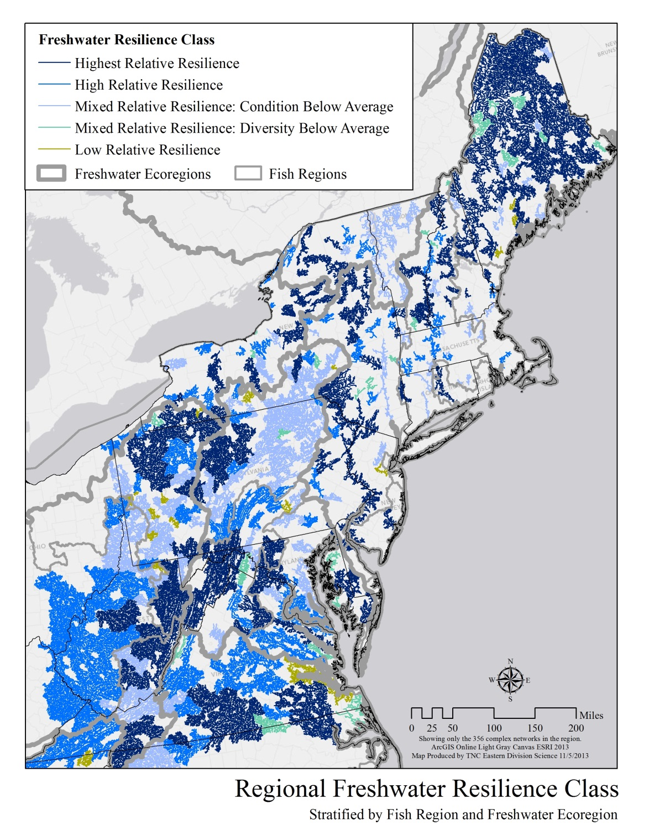

**Map 5. Comparison of TNC’s River Portfolio with the Resilience Rank Categories**. This map shows The Nature Conservancy’s portfolio rivers grouped by their rank categories for freshwater resilience. Portfolio rivers were identified as the best examples of various river types in the region. Sixty-three percent of the portfolio stream miles ranked as Highest or High Relative Resilience, based on their resilience characteristics.

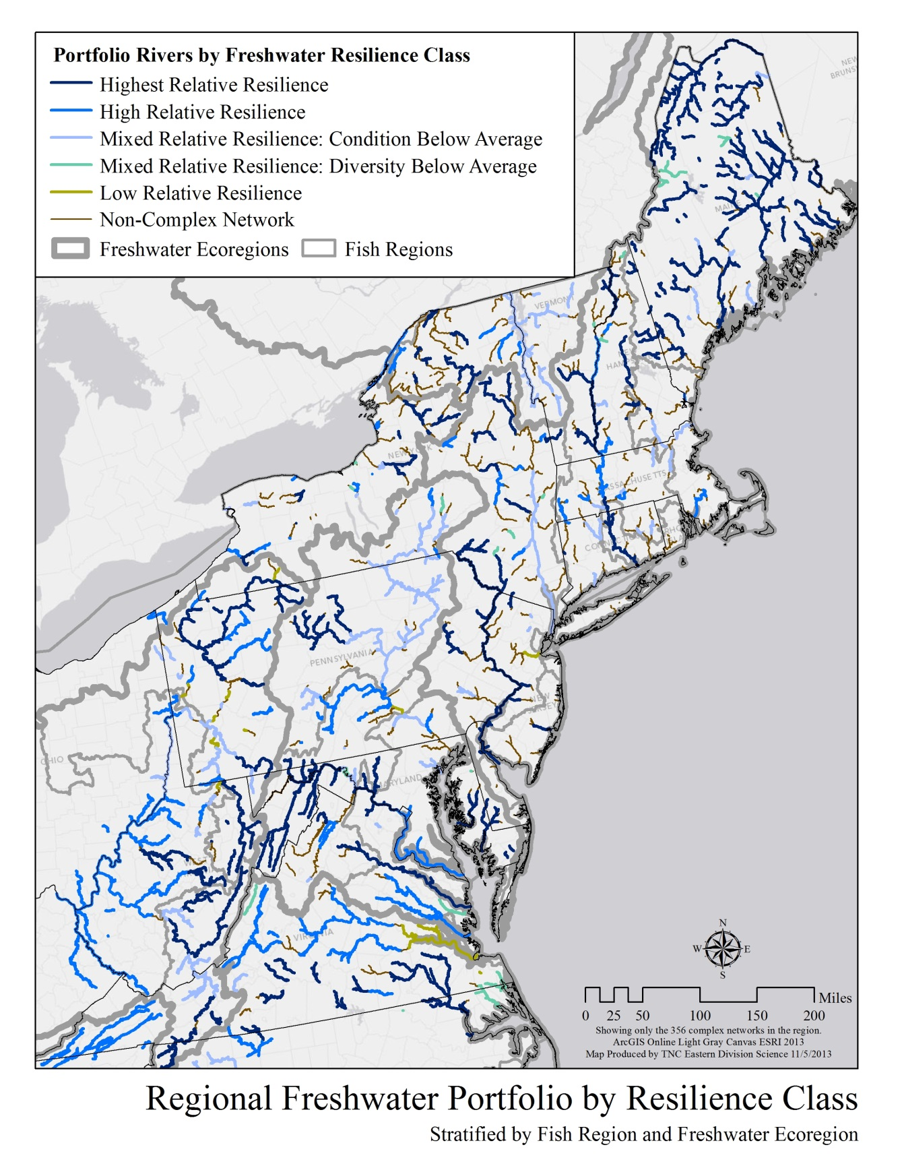

**Literature Cited**

Abell, R., M. Thieme, C. Revenga, M. Bryer, M. Kottelat, N. Bogutskaya, B. Coad, N. Mandrak, S. Contreras-Balderas, W. Bussing, M. L. J. Stiassny, P. Skelton, G. R. Allen, P. Unmack, A. Naseka, R. Ng, N. Sindorf, J. Robertson, E. Armijo, J. Higgins, T. J. Heibel, E. Wikramanayake, D. Olson, H. L. Lopez, R. E. d. Reis, J. G. Lundberg, M. H. Sabaj Perez, and P. Petry. 2008. Freshwater ecoregions of the world: A new map of biogeographic units for freshwater biodiversity conservation. BioScience 58:403-414.

Allan, J. D. 1995. Stream Ecology: Structure and Function of Running Waters. London: Chapman and Hall.

Anderson, M.G., M. Clark, and A. Olivero Sheldon. 2012. Resilient Sites for Terrestrial Conservation in the Northeast and Mid-Atlantic Region. The Nature Conservancy, Eastern Conservation Science. 168 pp.

Anderson, M.G., M. Clark, and A. Olivero Sheldon. 2011 Resilient Sites for Species Conservation in the Northeast and Mid-Atlantic Region. The Nature Conservancy, Eastern Conservation Science. 122pp.

Anderson, M.G. and A. Olivero Sheldon. 2011. Conservation Status of Fish, Wildlife, and Natural Habitats in the Northeast Landscape: Implementation of the Northeast Monitoring Framework. The Nature Conservancy, Eastern Conservation Science. 289 pp.

Anderson, M.G. and C.E. Ferree. 2010. Conserving the Stage: Climate Change and the Geophysical

Underpinnings of Species Diversity. PlosOne. July 2010 Volume 5, Issue 7. E11554 p 1-10

Anderson, M.G., C. Ferree, A. Olivero, and F. Zhao. 2010. Restoring Floodplain Forests using flow modeling and remote sensing to determine the best places for conservation. Natural Areas Journal 30:39-52

Angermeier, P.L, and M.R. Winston. 1998. Local vs. regional influences on local diversity in stream fish communities of Virginia. Ecology 79(3):911-927.

Bunn St. E., and Arthington, A.H. 2002. Basic Principles ofand Ecological Consequences of Altered Flwo Regimes for Aquatic Biodiversity. Environmental Management. Vol. 30, No. 4. p. 492-507.

Carlisle, D.M., D.M. Wolock, M.R. Meador. 2010. Alteration of streamflow magnitudes and potential

ecological consequences: a multiregional assessment. Frontiers in Ecology and the Environment. doi: 10.1890/100053

Center for Watershed Protection (CWP). 2003. Impacts of Impervious Cover on Aquatic Systems.

Watershed Protection Research Monograph No. 1.

Chu, C., Jones, N., Mandrak, N., Piggott, A., and, Minns, C. 2008. The influence of air temperature, groundwater discharge, and climate change on the thermal diversity of stream fishes in southern Ontario watersheds. Canadian Journal of Fisheries and Aquatic Sciences, 2008, Vol. 65, No. 2 : pp. 297-308

Cuffney, T. F., R. A. Brightbill, J. T. May, and I. R. Waite. 2010. Responses of benthic macroinvertebrates to environmental changes associated with urbanization in nine metropolitan areas. Ecological Applications 20: 1384-1401

Fitzhugh, T.W. and R.M. Vogel. 2010. The impact of dams on flood flows in the United States. River Research and Applications. doi: 10.1002/rra.1417

Frisell, C.A., W.J. Liss, C.E Warren, and M.D. Hurley. 1986. A hierarchical framework for stream habitat classification: viewing streams in a watershed context. Environmental Management 10(2): 199-214

Gunderson, L. H. 2000. Ecological resilience--in theory and application. Annual Review of Ecology and Systematics **31:**425-439.

Halliwell, D.B, Langdon, W.W., Daniels, R.A, Kurtenbach, J.P, and Jacobson, R.A. 1999. Classification of Freshwater Fish Species of the Northeastern United States for Use in the Development of Indices of Biological Integrity, with Regional Applications. Chpater 12, p301-333. Simon, T. 1999 edition. Assessing the Sustainability and Biological Integrity of Water Resources Using Fish Communities", CRC Press, Boca Raton/New York.

Higgins, J.V., M. Bryer, M. Khoury, and T. Fitzhugh. 2005. A Freshwater Classification Approach for

Biodiversity Conservation Planning. Conservation Biology 9:432-445

Hitt, N. P., and P. L. Angermeier. 2008a. Evidence for fish dispersal from spatial

analysis of stream network topology. Journal of the North American Benthological Society 27: 304-320.

Isaak, D.J., and Rieman, B.E. 2012. Stream isotherm shifts from climate change and implications for distributions of ectothermic organisms. Global Change Biology, doi: 10.1111 / gcb.12073

King, RS and ME Baker. 2010. Considerations for identifying and interpreting ecological community thresholds. Journal of the North American Benthological Association 29(3): 998-1008

Loarie, S., Duffy P, Hamilton, H., Asner, G., Field, C., and D. Ackerly. 2009. The velocity of climate change. Nature 462, 1052-1055 | doi:10.1038/nature08649;

Martin, E. H. and C. D. Apse. 2011. Northeast Aquatic Connectivity: An Assessment of Dams on Northeastern Rivers. The Nature Conservancy, Eastern Freshwater Program.

NatureServe. 2008. Watershed Distribution Maps of Freshwater Fishes in the Conterminous United States. Version 2. Arlington, VA. U.S.A.

Noe, G.B. and C.R. Hupp. 2005. Carbon, Nitrogen and Phosphorus accumulation in floodplains of Atlantic Coastal Plain rivers, USA. Ecological Applications 15(4): 1178-90.

Olivero, A., and M.G. Anderson. 2008. The Northeast Aquatic Habitat Classification. The Nature Conservancy, Eastern Conservation Science. 90 pp. <http://www.rcngrants.org/spatialData>

Palmer, M. A., Lettermajer, D.P, Poff, N. L, Postel, S.L., Richter, B., Warner, R. 2009. Climate Change and

River Ecosystems: Protection and Adaptation Environmental Management DOI 10.1007/s00267-009-9329-1

Poff, N.L. et al. 1997. The natural flow regime: A paradigm for river conservation and restoration.

BioScience 47(11): 769-84.

Poff, N. L. et al. 2010. The Ecological Limits of Hydrologic Alteration (ELOHA): A new framework for

developing regional environmental flow standards. Freshwater Biology. DOI: 10.1111/j.1365-2427.2009.02204.x

Postel, S. and B.D. Richter. 2003. Rivers for life: Managing water for people and nature.

Pringle, C.M. 2001. Hydrologic connectivity and the management of biological reserves: A global

perspective. Ecological Applications 11(4): 981-98.

Richter, B.D., J.V. Baumgartner, J. Powell and D.P. Braun. 1996. A method for assessing hydrologic

alteration in within ecosystems. Conservation Biology 10(4): 1163-74.

Rieman, B.E. and Isaak, D.J. 2010. Climate Change, Aquatic Ecosystems, and Fishes in the Rocky

Mountain West: Implications and Alternatives for Management. United States Department of Agriculture / Forest Service, Rocky Mountain Research Station. General Technical Report RMRS-=GTR-250

Smith, M.P., R. Schiff, A. Olivero, J. MacBroom. 2008. The Active River Area: A conservation framework

for protecting rivers and streams. The Nature Conservancy. 59 pp.

The Nature Conservancy (TNC). 2012. Eastern U.S. Ecoregional Assessments: Central Appalachian Ecoregion (2003), Chesapeake Bay Lowlands Ecoregion (2003), High Allegheny Ecoregion (2003), St. Lawrence Ecoregion (2003), Lower New England Ecoregion (2003), Northern Appalachian/Acadian Ecoregion (2006), North Atlantic Coast Ecoregion (2006). The Nature Conservancy, Eastern Conservation Science, Boston. Available from: http://conserveonline.org/workspaces/ecs/plans (accessed January 2012)

U.S. Geological Survey and U.S. Environmental Protection Agency. 2006. National Hydrography Dataset Plus (NHD-Plus). Version 1. 1:100,000.

U.S. Geological Survey. 2003. National Land Cover Dataset 2001 Imperviousness Dataset. Version 1. 30m cell. Sioux Falls, SD.

U.S. Geological Survey. 2011. National Land Cover Dataset 2006. Sioux Falls, SD <http://www.mrlc.gov/nlcd2006_downloads.php>

Vannote, R. L., G. W. Minshall, K. W. Cummins, J. R. Sedell, and C. E. Cushing. 1980. The river continuum concept. Canadian Journal of Fisheries and Aquatic Sciences 37: 130-137.

Violin, C. R., P. Cada, E. B. Sudduth, B. A. Hassett, D. L. Penrose, and E. S. Bernhardt. 2011. Effects of urbanization and urban stream restoration on the physical and biological structure of stream ecosystems. Ecological Applications, 21(6): 1932-1949.

Walker, B. H., L. H. Gunderson, A. P. Kinzig, C. Folke, S. R. Carpenter, and L. Schultz. 2006. A handful

of heuristics and some propositions for understanding resilience in social-ecological systems. Ecology and Society 11(1): 13. <URL:http://www.ecologyandsociety.org/vol11/iss1/art13/>

Wenger, S. J., J. T. Peterson, M. C. Freeman, B. J. Freeman, and D. D. Homans. 2008. Stream fish

occurrence in response to impervious cover, historic land use, and hydrogeomorphic factors. Canadian Journal of Fisheries and Aquatic Sciences 65: 1250-1264

Wehrly, K.E., Wang, L, and Mitro, M. 2007. Field-Based Estimates of Thermal Tolerance Limits for Trout: Incorporating Exposure Time and Temperature Fluctuation. Transactions of the American Fisheries Society 136:365-374.

Willis, K., and Bhagwat, S. 2009. Biodiversity and Climate Change. Science 326, 806-807 DOI: 10.1126/science.1178838

Zimmerman, J. 2006. Response of physical processes and ecological targets to altered hydrology in the Connecticut River basin. The Nature Conservancy, Connecticut River Program, Northampton, MA .

Zimmerman J. and A. Lester. 2006. Spatial distribution of hydrologic alteration and fragmentation among tributaries of the Connecticut River. The Nature Conservancy, Connecticut River Program, Northampton, MA.